**BCD Carpentry Project**

**BCD1-0117**

**System Installation and Configuration Manual**



|  |  |  |  |
| --- | --- | --- | --- |
| **Version** | **Description of Change** | **Author** | **Date** |
| 1.0 | Initial | Tao Sun | 09/04/2017 |
| 2.0 | Add IIS and Web Site section | Tao Sun | 15/05/2017 |
|  |  |  |  |

CONTENTS

1 Introduction 3

1.1 Purpose 3

1.2 Scope 3

2 Installation of SQL Server 2016 Express 3

2.1 Pre-requisites 3

2.2 Installation Procedure 3

2.2.1 Download SQL Server 2016 Express 3

2.2.2 Install SQL Server 2016 Express 4

2.2.3 Install SSMS 7

2.3 Create HRMSDB database and database objects 9

2.3.1 Execute “create-db.sql” 9

2.3.2 Execute “create-user.sql” 9

2.3.3 Create trigger and stored procedure 9

2.3.4 Install Microsoft Office Access database engine 2007 9

2.3.5 Import initial data 9

2.3.6 Change user’s password 10

2.3.7 Modify SQL Server setting permit SQL Server authentication. Restart SQL Server 10

3 Install and Configure IIS Server 10

3.1 Enable ASP.NET 10

3.2 Starting the IIS Web Server 12

4 Create Web Site Server 12

# Introduction

## Purpose

This document is provided to direct the user how to complete the works listed below:

* + - Download and install a SQL Server Express database on a Windows machine.
    - Install and configure an IIS Server for BCD Carpentry HRMS (Human Resource Management System) web application.
    - Deploy and configure the BCD HRMS web site.

## Scope

This document is intended for the BCD Carpentry project team and the IT staff of BCD Carpentry. It includes the details on how to install and configure the SQL Server database, IIS Server and the HRMS web application.

# Installation of SQL Server 2016 Express

## Pre-requisites

OS: Windows 10 (64 bit)

## Installation Procedure

### Download SQL Server 2016 Express

* **Download Address:** <https://www.microsoft.com/en-us/sql-server/sql-server-editions-express>
* **Download Page:**



Figure - 1

* **Operation:**

Click Download Now button and define the destination that SQL Server 2016 Express will be download to.

### Install SQL Server 2016 Express

**1. Double click the installation file downloaded before, you will see the page (Figure - 2) showed below. There are three options to choose and select the Basic.**

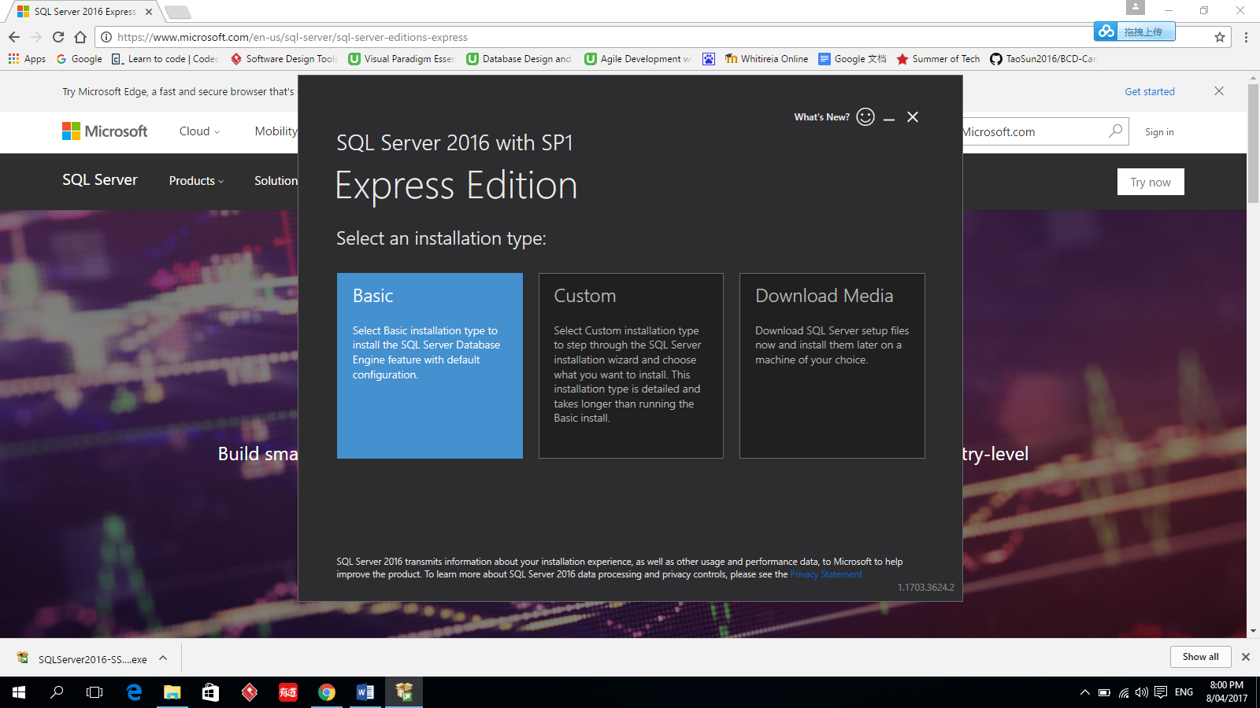

Figure – 2

**2. Accept the license terms**

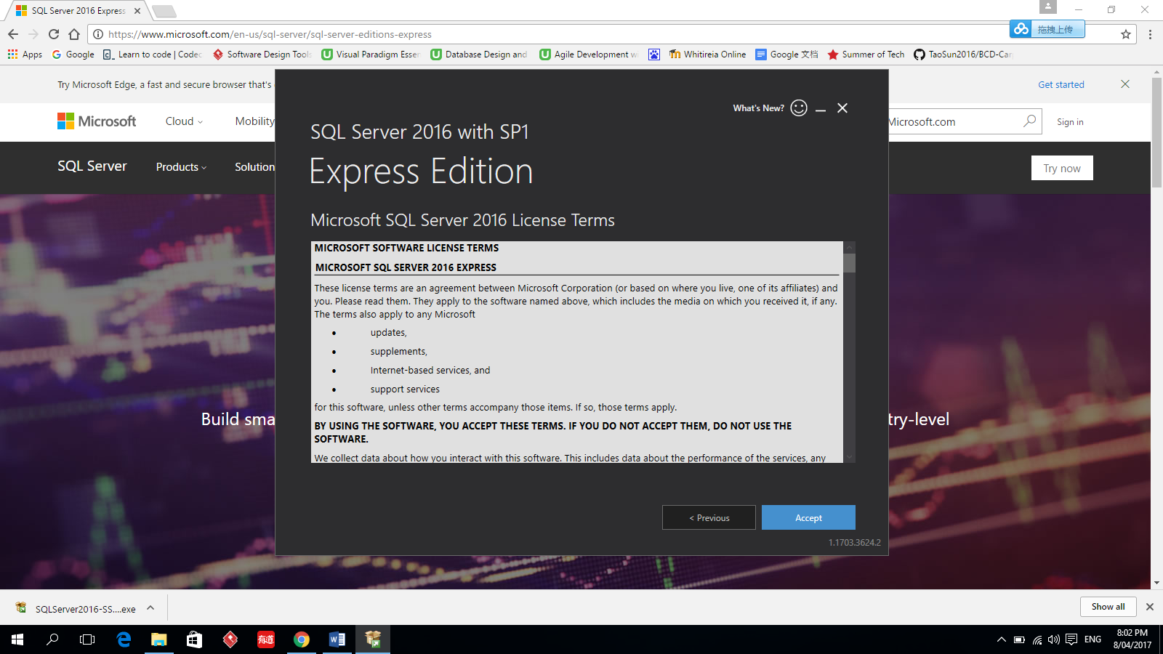

Figure – 3

**3. Set the install location and click install button.**

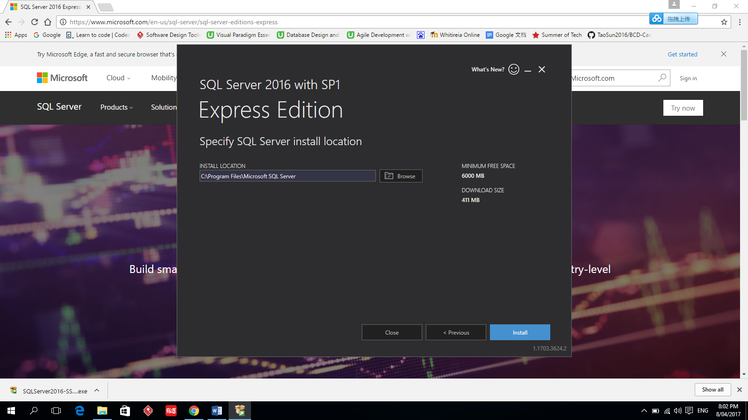

Figure - 4

**4. Wait for the completion of the installation. At the end, remember to click the install SSMS button to install SSMS.**

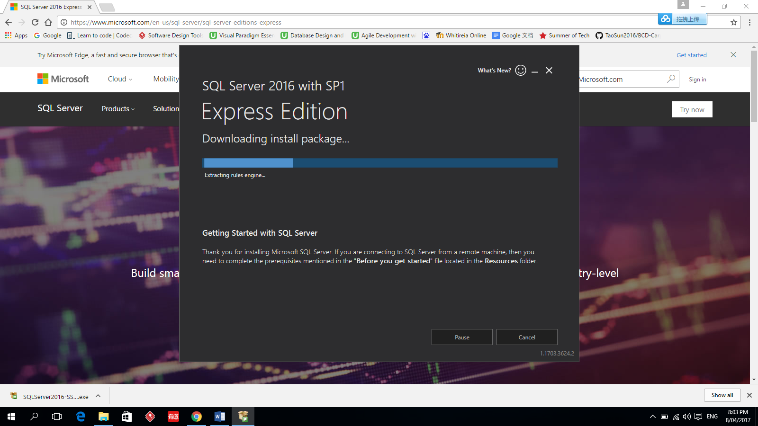

Figure - 5

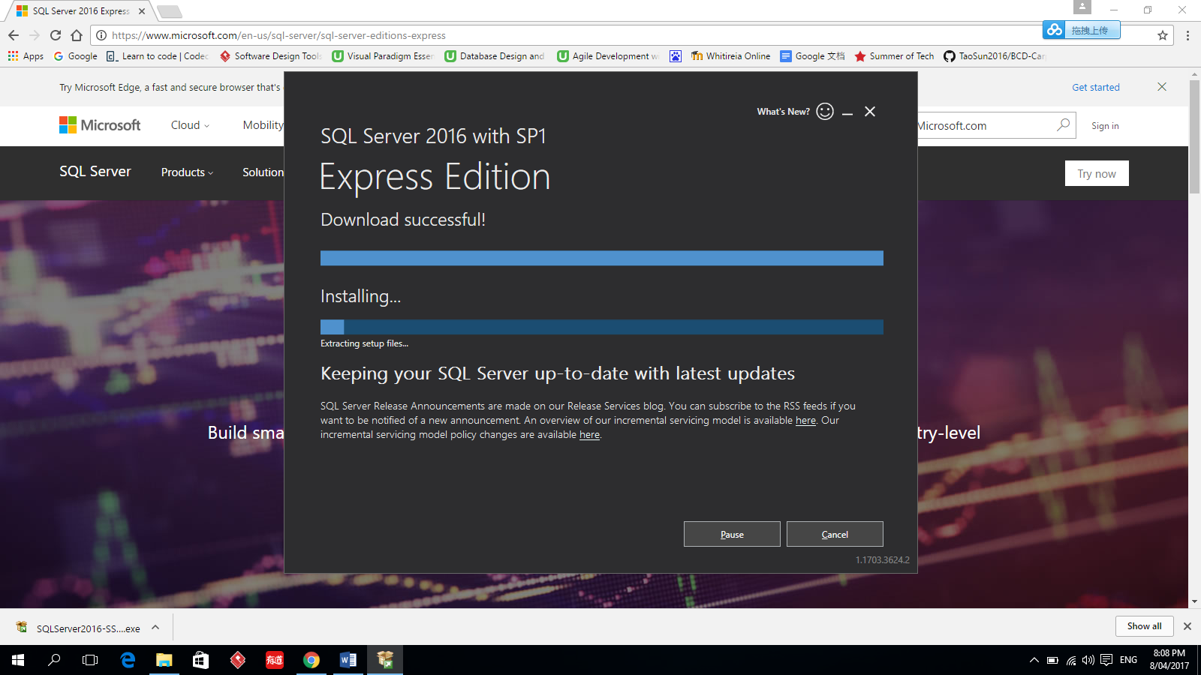

Figure - 6

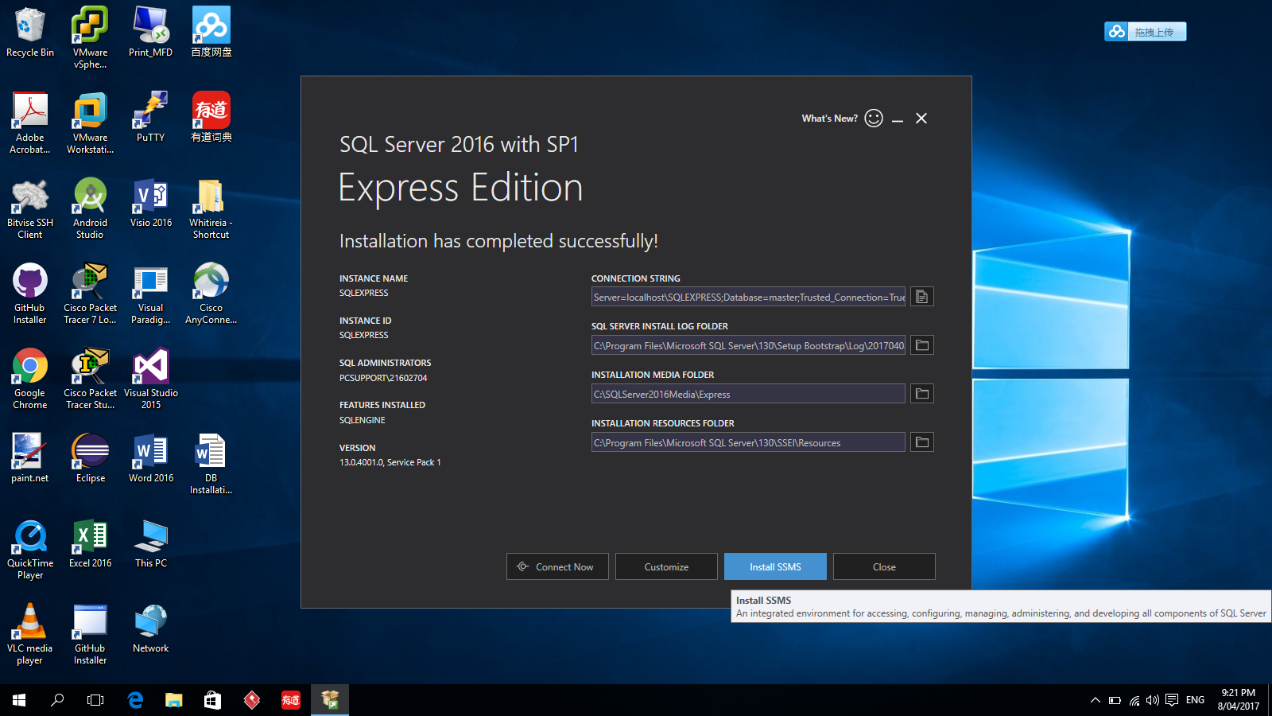

Figure - 7

**Click the install SSMS button.**

### Install SSMS

**1. Download SSMS**

When you click the install SSMS button, you will be redirected to the SSMS download web page (see Figure - 8).

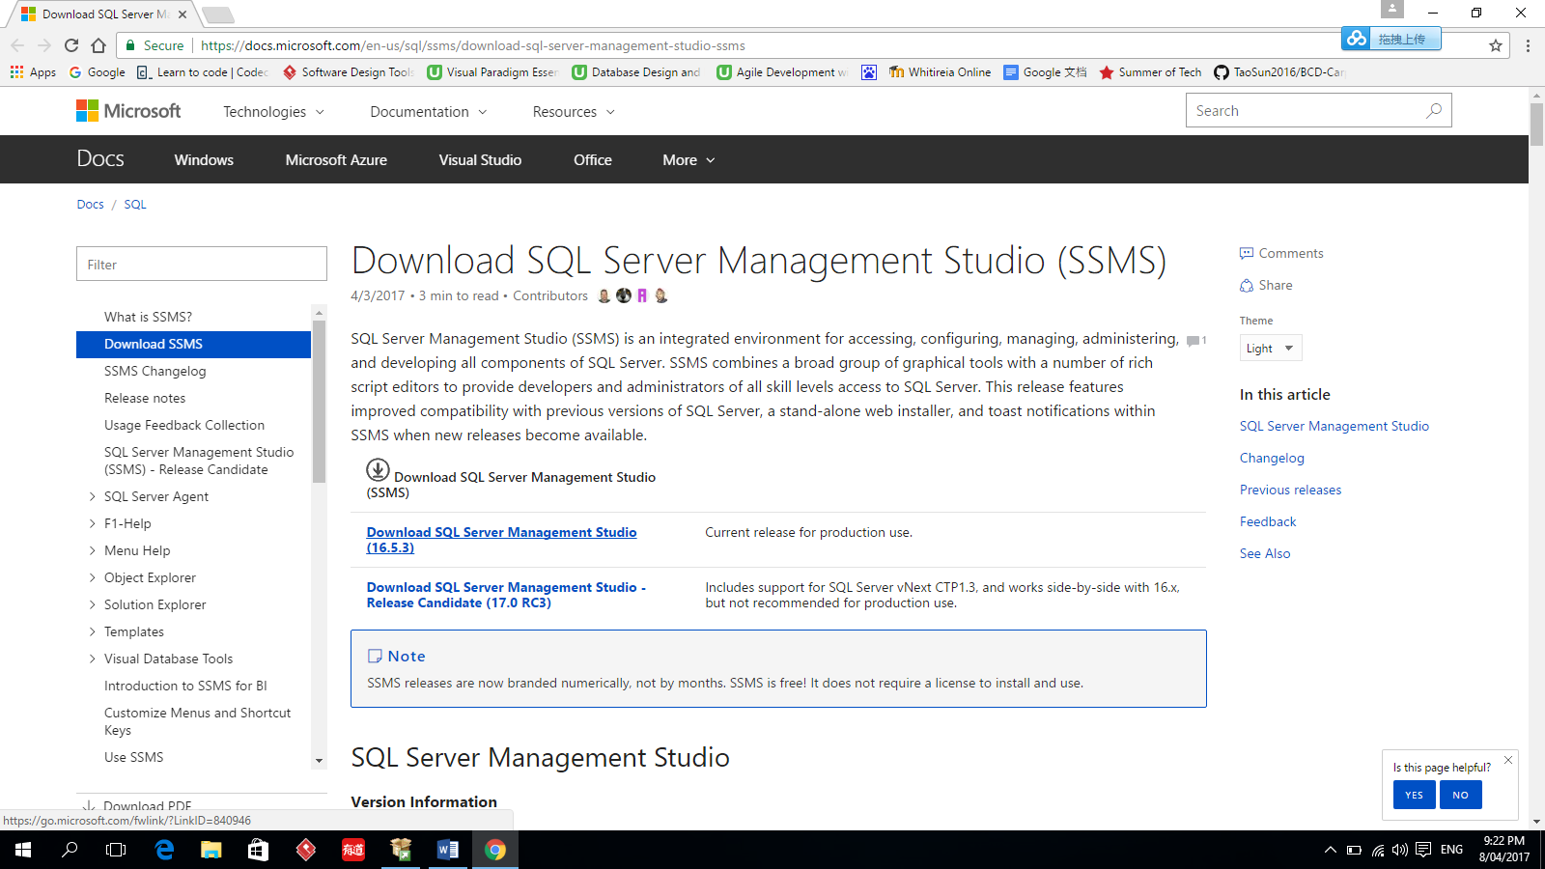

Figure – 8

**2. Install SSMS**

Double click the install file download in step 1, you will see the page like Figure – 9. Click Install button.

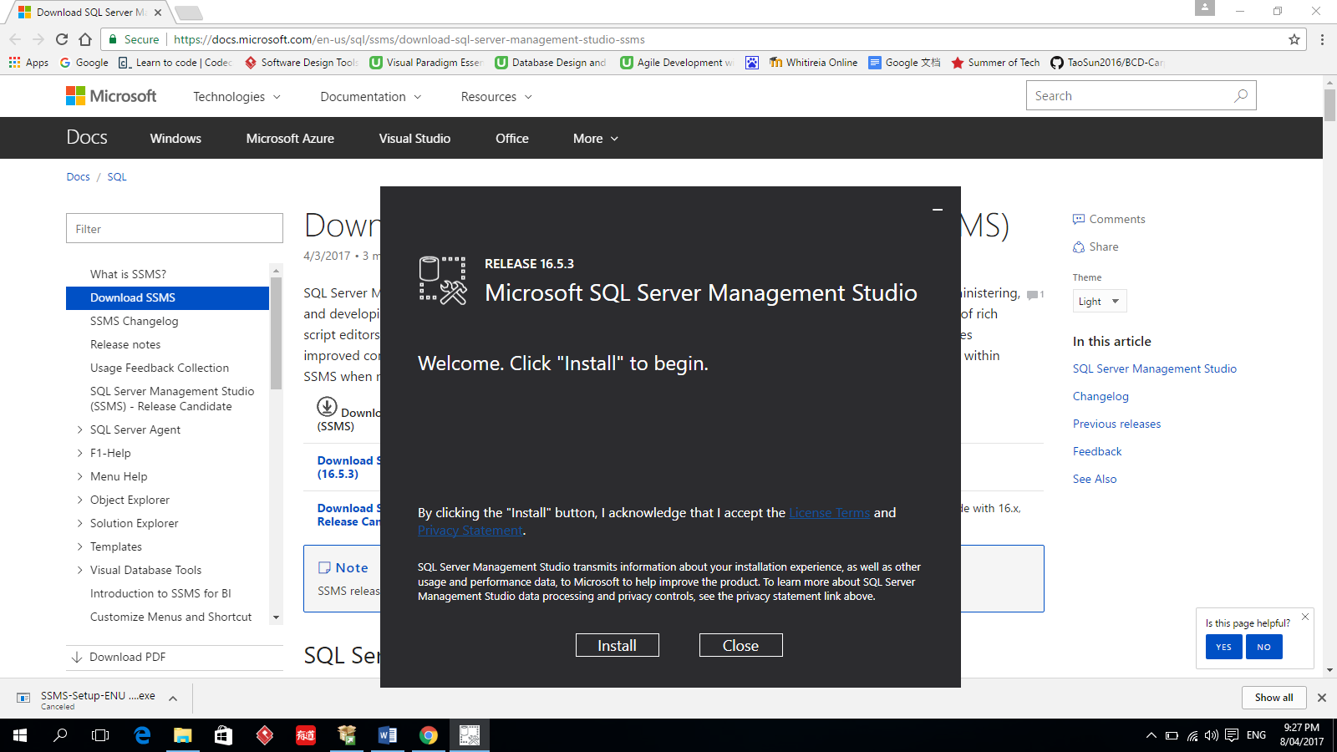

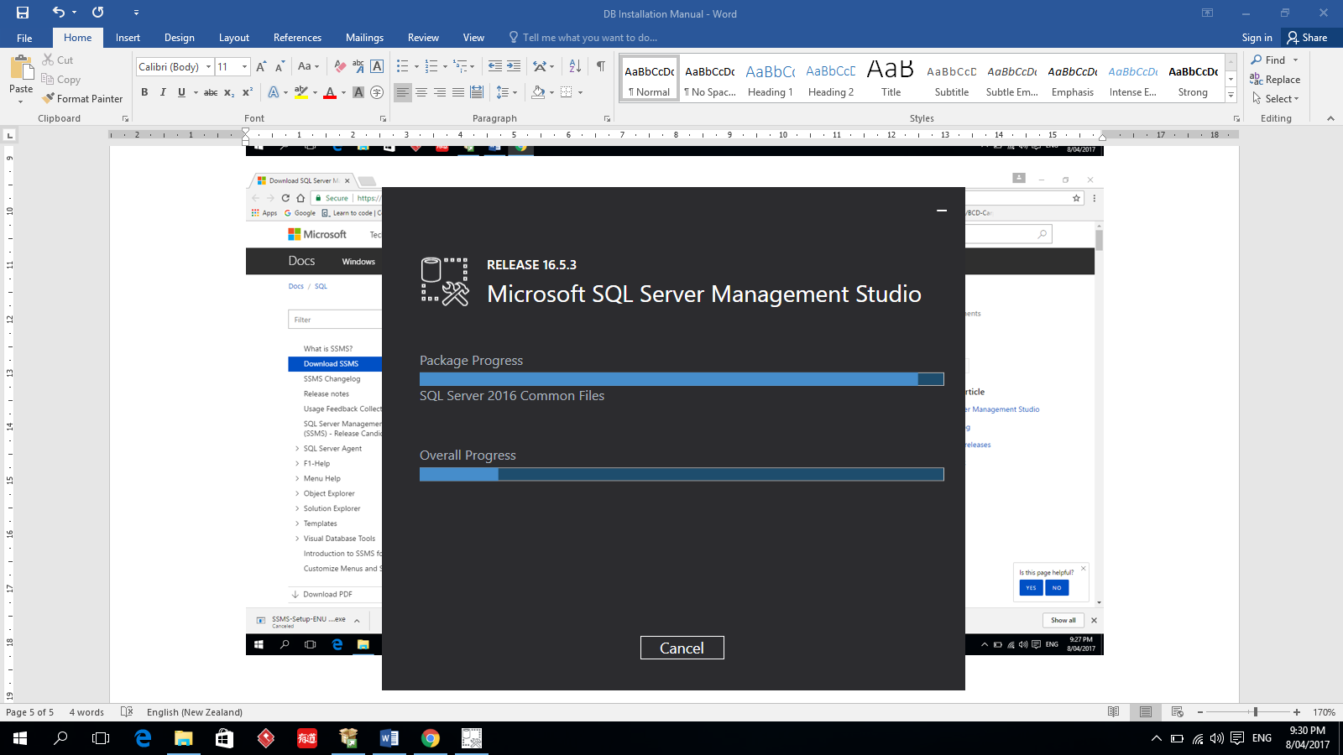

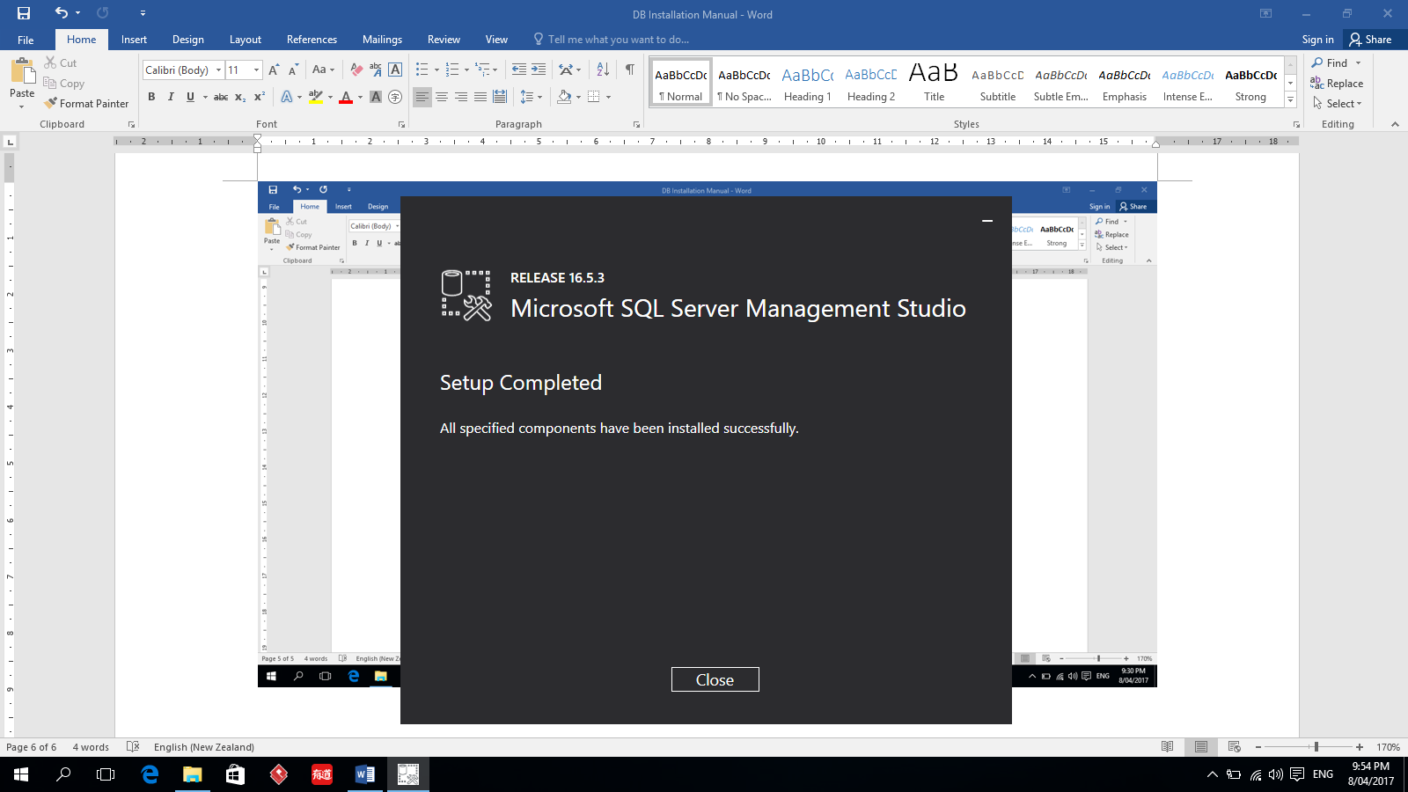

## Create HRMSDB database and database objects

### Execute “create-db.sql”

### Execute “create-user.sql”

### Create trigger and stored procedure

### Install Microsoft Office Access database engine 2007

### Import initial data

Position.xls

Employee.xls

Sys_Parameters.xlsx

### Change user’s password

### Modify SQL Server setting permit SQL Server authentication. Restart SQL Server

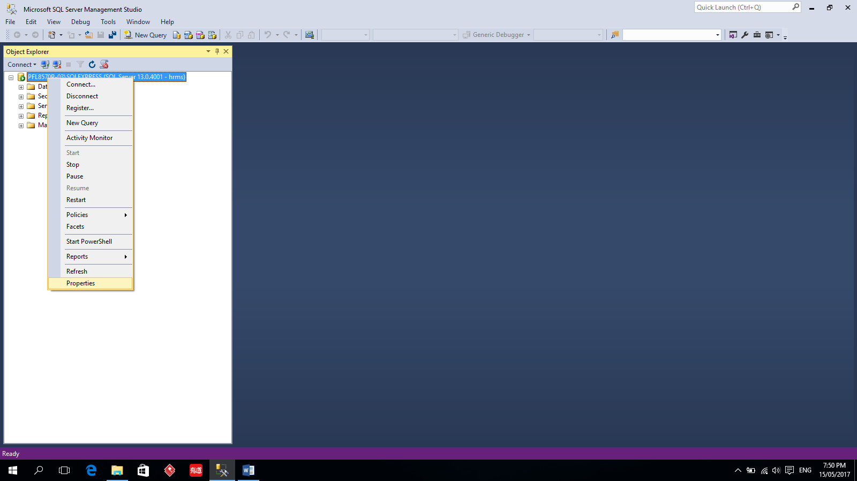

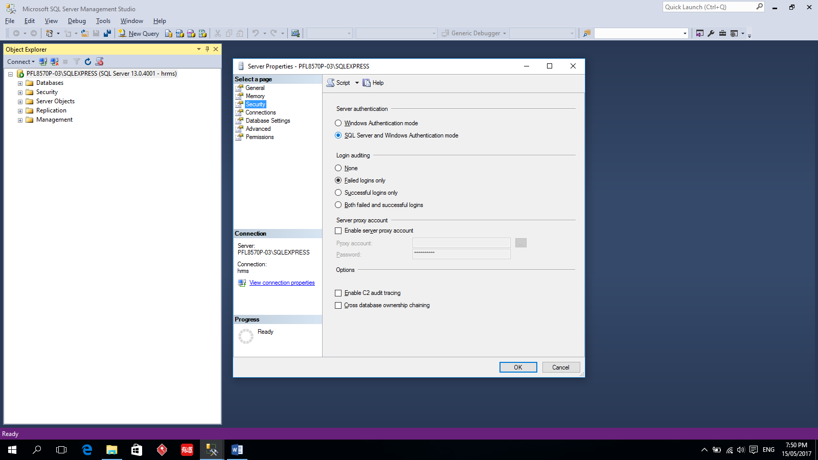

# Install and Configure IIS Server

## Enable ASP.NET

1. Open **Control Panel** and then click **Programs**.

2. Under **Programs and Features**, click **Turn Windows features on or off.**

If **Control Panel** is set to display in Classic view, click **Programs and Features**, and in then in the left pane, click **Turn Windows features on or off**.

3. Expand **Internet Information Services.**

4. Expand **Web Management Tools**, expand **IIS 6 Management Compatibility**

* + - **S**elect the **IIS 6 Metabase and IIS 6 configuration compatibility** check box.
    - Select the **IIS Management Console** check box

5. Expand **World Wide Web Services**, expand **Application Development Features**, and then select the **ASP.NET** check box.

6. Expand **World Wide Web Services**, expand **Security**, and then select the **Windows Authentication** check box.

7. Check Static Content and Default Document

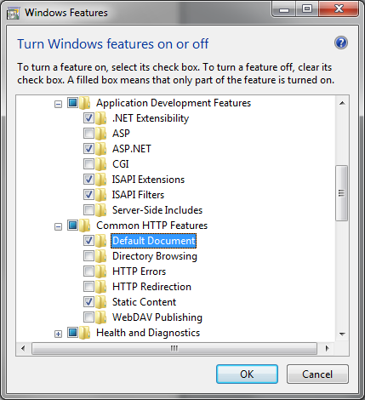

8. Check HTTP Activation

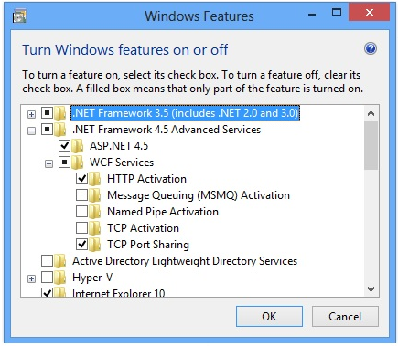

9. Click **OK** to start the IIS and ASP.NET installation process.

10. When the configuration process finishes, close Control Panel.

## Starting the IIS Web Server

1. Right click Start, choose **Computer Management.**

2. Expand **Services and Applications**, and then select **Internet Information Services (IIS) Manager**.

3. In the right pane, under **Connections**, expand the name of the **Web server** and then expand **Web Sites.**

4. Right-click **Default Web Site**, and then click **Start**.

# Create Web Site Server

1. Create a new folder in **C:\inetpub** called **BCDHRMS** and copy the files **iisstart.html** and **iisstart.PNG** from **C:\inetpub\wwwroot** to the new folder. These files will display the default web page that will confirm the correctness of the configuration steps we will perform below.
2. In **Internet Information Services (IIS) Manager**, in the **Connections** pane, select the **Default Web Site** and click on **Stop** in the **Actions** Pane. Right-click on the Sites node and select **Add Web Site**. Enter **BCDHRMS** as the site name in the dialog box and browse to the new folder you created to specify the new web sites physical location(**BCDHRMS**). Then click on OK.
3. In the **BCDHRMS** folder, create another folder named **hrms.**
4. Right click web site **BCDHRMS**, choose **Add Web Site** named **hrms** using the folder **hrms** as physical path.
5. Copy all the folders and files into **hrms** folder
6. Modify the connection strings in **web.config** file:

<connectionStrings>

connectionString="Data Source= hostname\SQLEXPRESS

1. Give full privileges to **everyone** on **images** folder

* right click **images** folder，choose **properties**

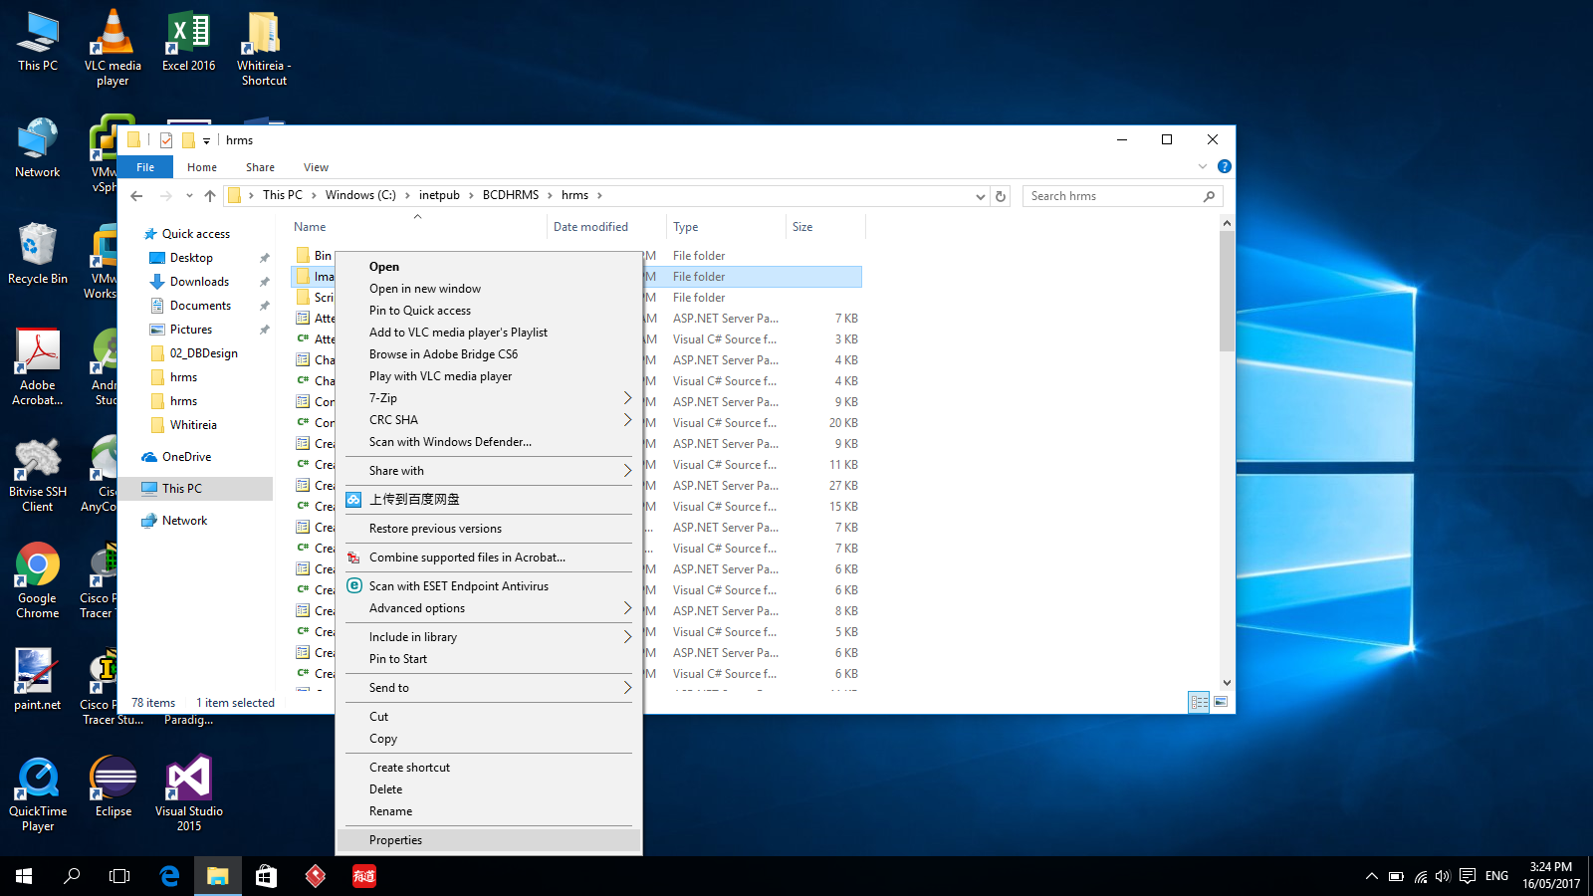

* click **Security** tab then click **Advanced** button

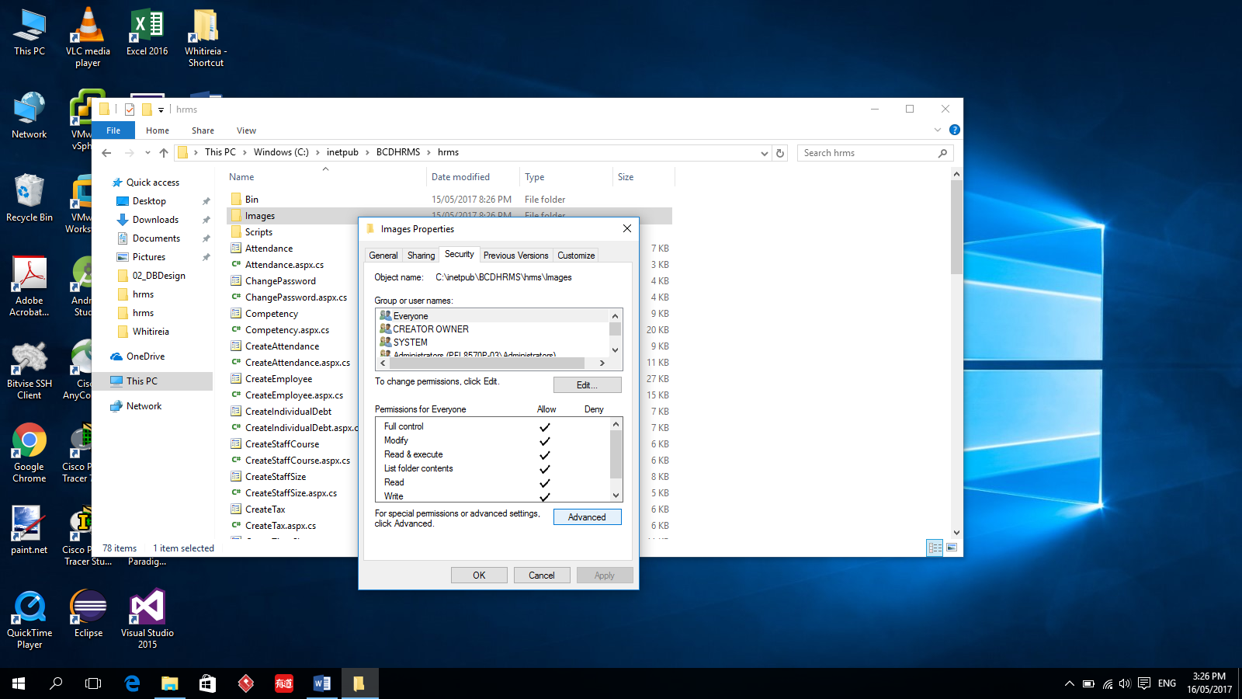

* Click **Add** button

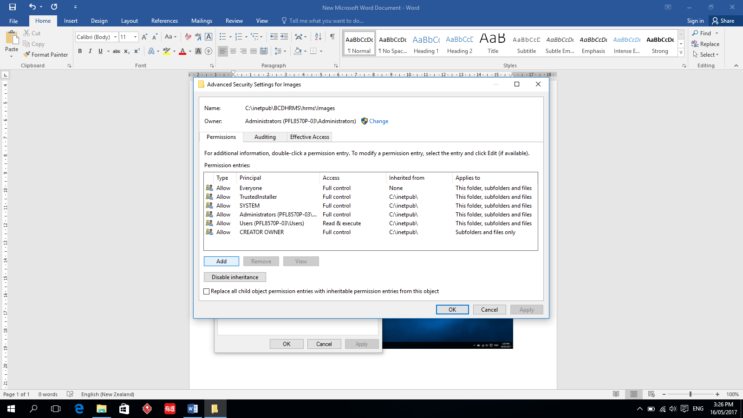

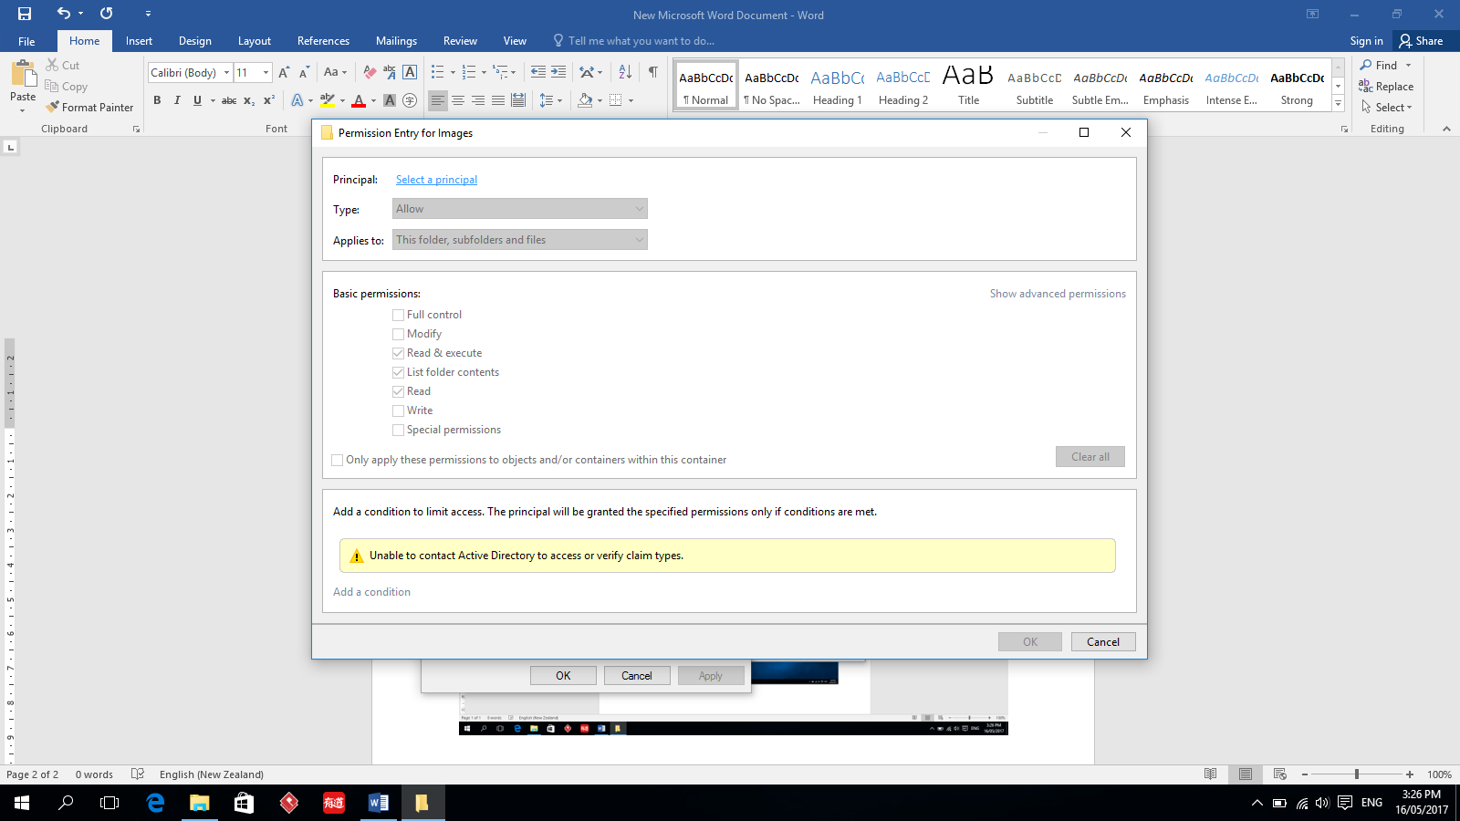

* Click **Select a principal**

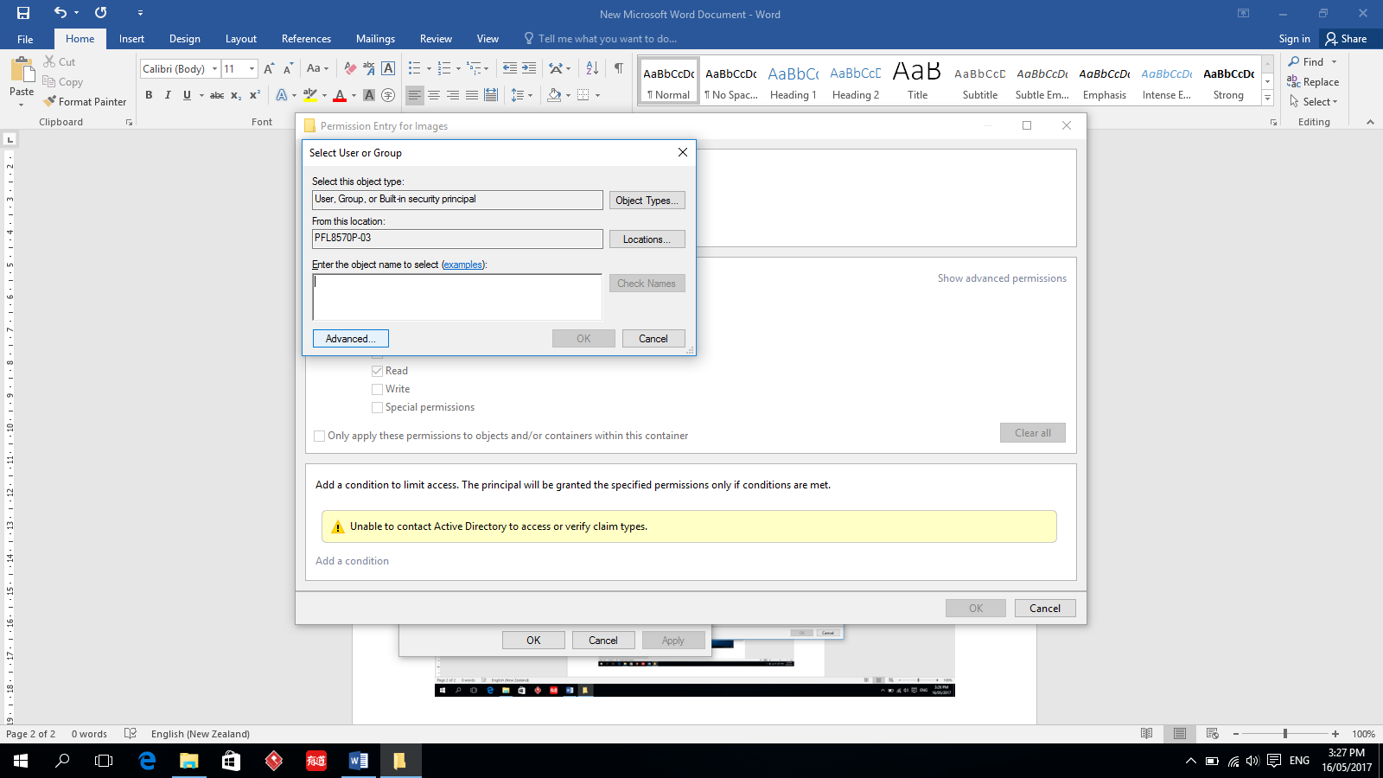

* Click **Advanced,** find user **everyone,** select **Full control** checkbox

